Katie Stanley

Evolution Final Project Draft

**Genotypic Variation of Hip Dysplasia in Dog Breeds**

**Introduction**

The domestic dog, Canis familiaris has been subject to directional selection for thousands of years. This dog can be classified based on breed types. Breeds have been selected for favorable phenotypic or behavioral traits (Honeycutt 2010). The canine genome has been shaped by rapid short-term evolution (Akey 2010).The diversification of dog breeds has led to the development of increased prevalence in genetic disorders (Sutter 2004).

Canine hip dysplasia(HD) is a genetic condition that involves a lack of veracity between the femoral head and acetabulum (Lust 1997). Hip dysplasia is a polygenic pathology(Brass 1989). This means that it can be influenced by environmental and genetic factors. Environmental factors proven to influence the phenotype can occur during hip development and stress during examination(Hedhammar 2007). Dysplastic parents tend to pass on mild to severe case of HD to their progeny (Hedhammar et al 1979). While the presence of Canine HD differs by breed (Loder 2017), it is one of the most prevalent diseases in dogs (Kaminaris 2012), and it often causes severe pain and various symptoms. In fact, HD often plays a major role in the decision to euthanize dogs. Tragically, HD is found to constituent greater than 50 per cent occurrence in most large breeds according to information from breeders and veterinarians (Riser 1963). ) The Veterinary Medical Database during the year 1964 and 2003, reported an increase in the prevalence of Canine HD (Witsberger 2008).

One approach to ameliorate this issue is selective breeding. Selective breeding tries to optimize good genes by breeding individuals that are not as susceptible to Canine hip dysplasia. This process attempts to select for phenotypic traits with a reduced the impact of canine HD. Selecting for reduced radiographic evidence of Canine HD pathology in a wide variety of phenotypes constituents selective breeding (Wilson 2011). Inheritability generally refers to traits that are entirely genetics based (Kapatkin 2002). A high heritability shows phenotypic variation can be explained by the genes and there is not environmental contributions and sampling error into the occurrence of HD. A low heritability can account for some genes that make HD prevalent but also, nongenetic factors such as diet. The degree of heritability will largely determine the success in removing HD from a certain breed of dogs.

HD is a major problem in dog breeds! While information exists on the prevalence of HD in different dog breeds at the Orthopedic Foundation for Animals and American Kennel Club, no studies have addressed the genetic variation of this disease in dog breeds that constituents selective breeding. The purpose of this study was to identify dog breeds with an increased inheritance of hip dysplasia and selective pressures to maintain pure-breed status. The authors believe that the study of HD among certain dog breeds will empower scientists to better understand inheritability of HD. This study hypothesized that genetic variation of HD in 129 dog breeds has increased prevalence and is evolutionary conserved.

**Materials and Methods**

*Hip dysplasia*

The prevalence of HD among dog breeds data was obtained from the Orthopedic Foundation of Animals(OFA), Karbe et al. 2012 and Durmis 2005 case studies. The OFA evaluated at minimum a fifty individuals from each breed category between the years 1974 thru 2019. All 129 breeds investigated in this study, HD diagnose was confirmed by pet health care professionals. The Karbe and Durmis prevalence data was included in this study to further support the Labrador Retriever and Pembroke Welch Corgi database. All data was collected by physical examination and radiographic diagnose. The data collected for each breed included the number of individuals evaluated for HD, the number that tested positive for HD and the percentage of individuals with HD if available. Three calculations were done to obtain the percentage, number of positive and genotype frequency of HD. The genotype frequencies of this study were conducted for the prevalence of canine Hip dysplasia using equation 1. The percentage of HD testing positive was conducted using equation 2.The number of dysplastic individuals were calculated using equation 3.

$$Equation 1: \left(\frac{\% of HD cases}{100}\right)=genotype of HP.$$

$Equation 2: \left(\#Number of hip\frac{displasia}{total}\right)*100=\% HP$

$Equation 3:(Covert percent to decimal* \#total number studied)=\# that had dysplasia$

Dog breeds being tested for hip dysplasia are often evaluated using a hip score estimate on a 1-18 scale from Normal to Severe HD but for this study all hip dysplastic individuals were characterized as testing positive or negative for HD based upon clinical diagnosis(Flückiger 2007). The data was analyzed using R Graphic programming platform (R Core Team, 2013). The bar graph was created using ggplot package.

*Heritability*

The heritability data was obtained from Oberbauer et al. Oberbauer et al obtained data for the OFA to calculate the genetic variation in hip dysplasia using heritability estimate hip scores. The top four most prevalent dog breeds identified based upon the previous section were analyzed using the heritability values obtained from Oberbauer et al. A linear regression graph was made in excel to demonstrate the percentage of inheritance of HD and the relationship among those four breeds.

**Results**

*Prevalence of canine HD in dog breeds.*

Table 1. A summary of the 129 domesticated dog breeds used in this study. Breeds are shown in are in alphabetic order (Data Obtained: OFA 2019, Karbe et al. 2012, Durmis 2005).

|  |  |
| --- | --- |
| **Breed** | **# of individuals with hip dysplasia** |
| PEMBROKE WELSH CORGI | 2827 |
| Rottweilers | 21682 |
| PUG | 617 |
| BULLDOG | 757 |
| OLDE ENGLISH BULLDOGGE | 93 |
| DOGUE DE BORDEAUX | 416 |
| NEAPOLITAN MASTIFF | 117 |
| BRUSSELS GRIFFON | 73 |
| ST. BERNARD | 1252 |
| OTTERHOUND | 257 |
| CLUMBER SPANIEL | 514 |
| BLACK RUSSIAN TERRIER | 386 |
| BOERBOEL | 126 |
| SUSSEX SPANIEL | 129 |
| AMERICAN BULLY | 53 |
| BASSET HOUND | 91 |
| PERRO DE PRESA CANARIO | 100 |
| DOGO ARGENTINO | 108 |
| FILA BRASILEIRO | 278 |
| CANE CORSO | 675 |
| AMERICAN BULLDOG | 805 |
| NORFOLK TERRIER | 130 |
| FRENCH BULLDOG | 722 |
| BOYKIN SPANIEL | 1393 |
| GLEN OF IMAAL TERRIER | 77 |
| AMERICAN STAFFORDSHIRE TERRIER | 974 |
| BLOODHOUND | 867 |
| NEWFOUNDLAND | 4634 |
| BULLMASTIFF | 1713 |
| MAINE COON CAT | 960 |
| SPANISH WATER DOG | 65 |
| LAGOTTO ROMAGNOLO | 112 |
| AMERICAN PIT BULL TERRIER | 221 |
| CARDIGAN WELSH CORGI | 643 |
| SHIH TZU | 185 |
| CENTRAL ASIAN SHEPHERD | 23 |
| ENGLISH SHEPHERD | 148 |
| CHOW CHOW | 1263 |
| LLEWELLIN SETTER | 21 |
| MASTIFF | 2638 |
| GERMAN SHEPHERD | 26372 |
| SHILOH SHEPHERD | 265 |
| NORWEGIAN ELKHOUND | 863 |
| GOLDEN RETRIEVER | 31843 |
| CHESAPEAKE BAY RETRIEVER | 2953 |
| LOUISIANA CATAHOULA LEOPARD | 149 |
| OLD ENGLISH SHEEPDOG | 2263 |
| GORDON SETTER | 1280 |
| AFFENPINSCHER | 81 |
| HYBRID | 745 |
| KUVASZ | 362 |
| GIANT SCHNAUZER | 906 |
| GREATER SWISS MOUNTAIN DOG | 678 |
| ICELANDIC SHEEPDOG | 127 |
| BEAGLE | 215 |
| EPAGNEUL BRETON | 52 |
| BERGER PICARD | 60 |
| FIELD SPANIEL | 229 |
| WHITE SHEPHERD | 29 |
| CHINOOK | 163 |
| MAREMMA SHEEPDOG | 23 |
| AUSTRALIAN CATTLE DOG | 803 |
| POLISH LOWLAND SHEEPDOG | 105 |
| ENTLEBUCHER | 77 |
| HAVANA SILK DOG | 36 |
| TIBETAN MASTIFF | 195 |
| POMERANIAN | 29 |
| BERNESE MOUNTAIN DOG | 3953 |
| CHINESE SHAR-PEI | 1686 |
| ENGLISH SETTER | 1906 |
| CURLY-COATED RETRIEVER | 208 |
| STAFFORDSHIRE BULL TERRIER | 137 |
| PYRENEAN SHEPHERD | 33 |
| SPINONE ITALIANO | 249 |
| BOUVIER DES FLANDRES | 1430 |
| HARRIER | 56 |
| BLACK AND TAN COONHOUND | 124 |
| CAVALIER KING CHARLES SPANIEL | 1278 |
| AUSTRALIAN LABRADOODLE | 113 |
| BRITTANY | 3015 |
| LEONBERGER | 352 |
| BRIARD | 397 |
| NORWICH TERRIER | 194 |
| SMOOTH FOX TERRIER | 66 |
| WELSH TERRIER | 19 |
| AKITA | 2398 |
| BARBET | 29 |
| STABYHOUN | 23 |
| KOMONDOR | 137 |
| GREAT DANE | 2039 |
| ENGLISH SPRINGER SPANIEL | 2277 |
| PORTUGUESE WATER DOG | 1296 |
| MUNSTERLANDER | 33 |
| BRACCO ITALIANO | 16 |
| BOXER | 812 |
| WEST HIGHLAND WHITE TERRIER | 74 |
| TIBETAN SPANIEL | 47 |
| PETIT BASSET GRIFFON VENDEEN | 97 |
| IRISH SETTER | 1504 |
| LABRADOR RETRIEVER | 33,108 |
| ALASKAN MALAMUTE | 1808 |
| POODLE | 3705 |
| PUDELPOINTER | 76 |
| IRISH WATER SPANIEL | 187 |
| AIREDALE TERRIER | 783 |
| BEAUCERON | 75 |
| BOSTON TERRIER | 45 |
| WELSH SPRINGER SPANIEL | 290 |
| SAMOYED | 2035 |
| SWEDISH VALLHUND | 44 |
| AKBASH DOG | 64 |
| MALTESE | 13 |
| BORDER COLLIE | 1635 |
| PULI | 197 |
| WIREHAIRED VIZSLA | 24 |
| CAIRN TERRIER | 14 |
| LARGE MUNSTERLANDER | 12 |
| ANATOLIAN SHEPHERD | 242 |
| COTON DE TULEAR | 105 |
| GREAT PYRENEES | 638 |
| FRENCH SPANIEL | 22 |
| HAVANESE | 504 |
| AMERICAN ESKIMO DOG | 112 |
| FINNISH LAPPHUND | 31 |
| GERMAN WIREHAIRED POINTER | 443 |
| NORWEGIAN BUHUND | 25 |
| WEIMARANER | 1165 |
| STANDARD SCHNAUZER | 414 |

129 dog breeds have tested positive for hip dysplasia. The prevalence of hip dysplasia differs among breeds. Some breeds are more, likely based on case studies, to have hip dysplasia at one point of their life. Although 1,955,115, total individuals from all the breeds listed above were evaluated for hip dysplasia, only 195,274 individuals tested positive. The breed names used for HD groupings throughout this study are listed above. The number of cases that were clinically confirmed is indicated above and represents the prevalence of HD, using random samples sizes of each specific breed to test for HD(Table 1).

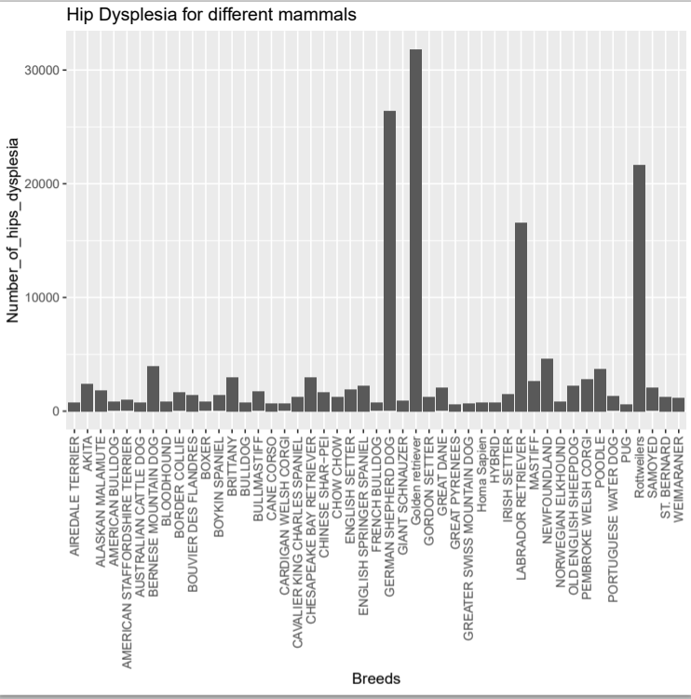

Figure 1. A comparison of the number of HD cases across dog breeds. Breeds are shown in alphabetic order (see Supporting Information Tables 1 for the complete lists of 129 domesticated breeds used in this study). Forty-Seven breeds are shown above that make up the top ninety percent of observed cases of HD in this case study (Data Obtained: OFA 2019, Karbe et al. 2012, Durmis 2005).

The number of positive cases identified for HD that are included in the database are identified between the years of 1900-2019. 192,862 dysplastic individuals were identified among the 129 breeds used in this study. Forty-seven breeds were identified to encompass the largest number of HD cases among the cumulation of breeds. The largest numbers of identified cases among the breeds were identified in four breeds; Golden Retriever, German Shepherd, Rottweilers and Labrador Retriever. The four breeds are listed in descending order. The Golden Retriever had the largest number of identified cases of HD, 31,843. The second largest number of identified cases were the German Shepherds, at 26,372. Rottweilers had the third most identified cases of HD, 21,682. Labrador Retrievers were identified to have fourth largest identified cases of HD, 16,553 cases. All the other forty-three breeds showed significantly less positive HD cases as the number of cases did not exceed 5,000 (Figure 1).

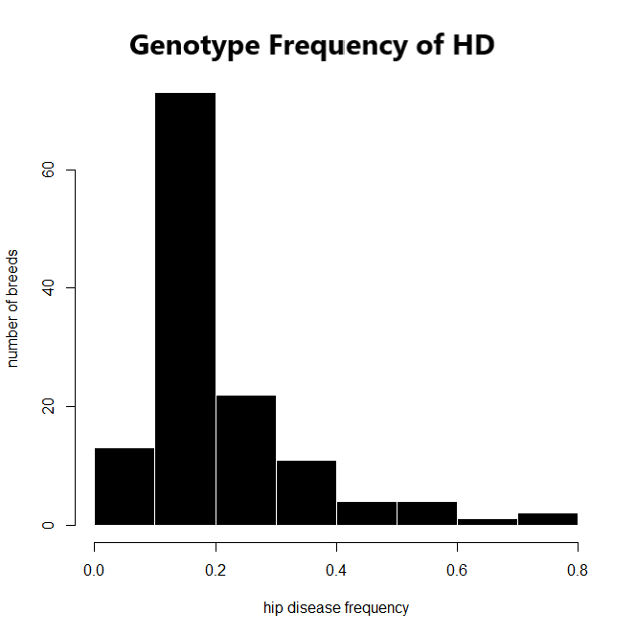

Figure 2. The genotype frequencies obtained for prevalence of hip dysplasia based on the current available data. 129 dog breeds were evaluated based upon the frequency as to which there clinical diagnose has been confirmed as HD. The genotype frequencies of HD diagnosis, ranges between 0.0-0.8 (Data Obtained: OFA 2019, Karbe et al. 2012, Durmis 2005).

The prevalence of dog breeds to obtain a clinical diagnosis of HD, can be calculated as the genotype frequency. The genotype frequency ranges between 0.0-0.8, are the chances that HD can be found in any one breed type. Over a hundred dog breeds show a low frequency of 0.2, prevalence in the number of individuals testing positive for HD. As frequency increases, those breed types are less likely to be diagnose positive for HD compared to the other 128 breeds. As frequency increases, those breed types are more likely to be diagnosed for HD, compared to the rest of the breeds (Figure 2).

*The heritability of canine HD among four domesticated breeds.*

Table 2: The heritability score to obtain HD among the four breeds that had the highest prevalence of HD among 129 domesticated dog breeds (Data Obtained from: Oberbauer et al. 2017).

|  |  |
| --- | --- |
| **Breed** | **Heritability of Hip Score** |
| GOLDEN RETRIEVER | 0.65±0.03 |
| LABRADOR RETRIEVER | 0.59±0.5 |
| GERMAN SHEPHERD | 0.58±0.03 |
| Rottweilers | 0.57±0.02 |

Figure 3: Four breeds were compared to the percent of inheritance they display based upon table 2. The four breeds include Golden Retriever (GR), Labrador Retriever(LR), German Shepherd(GS) and Rottweiler(R) (Oberbauer et al. 2017).

The four breeds with the most recorded cases of HD in the current OFA data show that HD is between 57-65% highly heritable among the four breeds (Table 2). Golden retrievers are the most likely to inherit hip dysplasia. Labrador Retriever, German Shepherds and Rottweilers have roughly 60 % chance of inheriting HD (Figure 3).

**Discussion**

The phenotypic characteristic of dog body size seems to be playing a role in the appearance of HD. In this study we identified the pure breed inheritance and prevalence values of HD. The four breeds with the largest number of HD cases included the Golden Retriever, Labrador Retriever, German Shepherd and Rottweiler. Those breeds are typically 30kg or more in weight classifying them as large dog breeds(Candine 2018). The Golden Retriever, Labrador Retriever, German Shepherd and Rottweiler were affected by environmental and diagnostic error. The Golden Retriever out of those breeds had the highest inheritance percentage of HD based on from parent to offspring indicating that over sixty-five percent of the prevalence of HD in due solely to genetics for this breed. While less than sixty-five percent in the other three breeds. These four breeds are still genetically pre-disposed to HD based on genetic factors, environmental influences and diagnostic error. All four breeds showed a high heritability of HD indicating that selected phenotypic traits among the breeds can influence HD.

Although breeders are attempting to selective breed these large dogs by individuals with less or no prevalence of HD. Inbreeding may be the best option and that to increases the risk of genetic disorders(KC 2020). HD still plays a major role in the genetics of these breeds and therefore over fifty percent evolutionary conserved disease pathology. This study supported the hypothesis that certain breeds are more prone to HD, heritability an inheritability can influence the breeds prevalence for the diagnoses. Further investigation on other phenotypic characteristics such as the heritability difference among the genders and breeds determined to be HD positive could result could further explain the frequencies of HD among the breeds. There is rutmetry biological differences between the sexes, gender specific disease research compared to the current data, may change the prevalence pattern among breeds. As prevalence of HD, continue to increase among canines the health of our canine friends can be greatly impacted by helping our dogs maintain a normal body weight in dogs as seen in clinical studies( Impellizeri, 2000).

Sources

Akey, Joshua M. et al. “Tracking footprints of artificial selection in the dog genome.” Proceedings of the National Academy of Sciences of the United States of America 107 3 (2010): 1160-5 .

Candine. Interesting facts about dog breeds in India. LinkedIn(2018).https://www.slideshare.net/canidine/breed-box

Durmus et al. “Hip dysplasia in Labrador Retrievers in Turkey” Journal of Animal and Veterinary Advances.Vol.3; 385-386, (2005).

Flückiger, Mark. Scoring radiographs for canine Hip Dysplasia.The big three organisations in the world.The European Journal of Companion Animal Practice. VOL. 17 - (2) - OCTOBER 2007 ISSN 1018-2357

Karbe GT, Biery DN, Gregor TP, Giger U, Smith GK. 2012. Radiographic Hip Joint Phenotype of the Pembroke Welsh Corgi. Veterinary Surgery. 41(1):34–41. doi:10.1111/j.1532-950X.2011.00938.x.

J. Bouw (1982) Hip dysplasia and dog breeding, Veterinary Quarterly, 4:4,173-181, DOI: 10.1080/01652176.1982.9693859

Sutter NB, Ostrander EA (2004) Dog star rising: the canine genetic system. Nat Rev Genet 5:900–910

Honeycutt RL. Unraveling the mysteries of dog evolution. BMC Biol. 2010;8:20. Published 2010 Mar 9. doi:10.1186/1741-7007-8-20

Lust G. An overview of the pathogenesis of canine hip dysplasia. Journal of the American Veterinary Medical Association. 1997 May;210(10):1443-1445.

Kaminaris, , Alexandros. “Canine hip displasia: PennHip compared to OFA, FCI and BVA/CK.” Hungarian Veterinary Archive.(2012): <http://hdl.handle.net/10832/417>

Brass.W. “Hip dysplasia in dogs.” Journal of Small Animal Practice (1989)30, 166-170

Riser, Wayne. “A New Look at Developmental Subluxation and Dislocation: Hip Dysplasia in the Dog” School of Veterinary Medicine(1963) Vol.4, pp. 42 1 to 434.

Witsberger TH et al. Prevalence of and risk factors for hip dysplasia and cranial cruciate ligament deficiency in dogs. J Am Vet Med Assoc. 2008 Jun 15;232(12):1818-24. doi: 10.2460/javma.232.12.1818.

Wilson, Bethany et al. Selection against canine hip dysplasia: Success or failure? The Veterinary Journal.Volume 189, Issue 2, August 2011, Pages 160-168https://doi.org/10.1016/j.tvjl.2011.06.014

HEDHAMMAR, A., OLSSON, S.E., ANDERSSON, S.A. et al. Canine hip dysplasia: study of heritability in 401 litters of german shepherd dogs. J. Am. Vet. Med. Assoc., v.174, p.1012-1016, 1979.

Hedhammar, A.Canine Hip Dysplasia as influenced by genetic and environmental factors.The European Journal of Companion Animal Practice. VOL. 17 - (2) - OCTOBER 2007 ISSN 1018-2357

Kapatkin, A et al. Genetic Control of Canine Hip Dysplasia. University of Pennsylvania. Vol. 24, No. 9 September 2002

Loder RT, Todhunter RJ. The Demographics of Canine Hip Dysplasia in the United States and Canada. J Vet Med. 2017;2017:5723476. doi:10.1155/2017/5723476

R Core Team (2013). R: A language and environment for statistical computing. R Foundation for Statistical Computing, Vienna, Austria. URL <http://www.R-project.org/>.

Oberbauer AM, Keller GG, Famula TR (2017) Long-term genetic selection reduced prevalence of hip and elbow dysplasia in 60 dog breeds. PLoS ONE 12(2): e0172918. https://doi.org/10.1371/journal.pone.0172918

OFA. Hip displasia stastics. Orthopedic Foundation for Animals(2020).https://www.ofa.org/diseases/breed-statistics#detail

KC. Gene pools and the impact of selection. 2020. <https://www.thekennelclub.org.uk/health/for-breeders/understanding-canine-genetics/breeds-and-their-gene-pool/>

Impellizeri, Joseph et al. Effect of weight reduction on clinical signs of lameness in dogs with hip osteoarthritis. Journal of the American Veterinary Medical Association. 2000, Vol. 216, No. 7, Pages 1089-1091. https://doi.org/10.2460/javma.2000.216.1089